VAGINOV, Konstantin Konstantinovich Wagenheim (ВАГИНОВ, КОНСТАНТИН КОНСТАНТИНОВИЧ ВАГЕНГЕЙМ) (1899-1934)

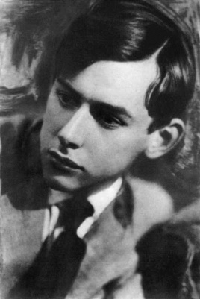
Russian poet and novelist who at different points was affiliated with a number of literary groups in Petrograd/Leningrad. The theme of the northern capital where he spent most of his life occupies a central position in his writings. He is best known for his four novels in which he ironically depicts the demise of Russia’s pre-revolutionary Silver Age in the Soviet Union of the late 1920s-early 1930s. Born on April 16, 1899 in St. Petersburg, died in Leningrad on April 26, 1934. Born Konstantin Konstantinovich Wagenheim, Vaginov grew up in the family of a high ranking police official of German (and possibly Jewish) background. The family Russified their name after the start of World War I. Vaginov attended the Law Faculty of Petrograd University from where he was called up to join the Red Army in 1919. Upon return to his home city, he was active in several literary circles, including Acmeist Nikolai GUMILEV’s Poets’ Guild which he joined in 1921; he also co-founded the group Islanders in whose collected volume his poetry was first published. In 1924, Vaginov met the critic and philosopher Mikhail Bakhtin; members of Bakhtin’s intellectual circle later served as prototypes for his first novel Goat Song (1927). From 1927 Vaginov was affiliated with the avant-garde group OBERIU, and together with its key members, participated in Oberiu’s famous evening “Three Left Hours” which he parodied in his second novel Works and Days of Svistonov (1929). In 1931, Vaginov was subjected to a vicious attack by members of the proletarian writers’ group RAPP. His last two prose works Bambocciada (1931) and Harpagoniana (1933, unpublished in Vaginov’s lifetime) explore many of the same themes as his first two novels but in them irony and carnival give way to grotesque. Vaginov died of tuberculosis in 1934, after a long illness.

References and Further Reading:
Roberts, Graham (1997) The Last Soviet Avangt-garde: OBERIU—Fact, Fiction, Metafiction. Cambridge: Cambridge University Press, 1997.
Shepherd, David (1992) Beyond Metafiction: Self-Consciousness in Soviet Literature. Oxford: Clarendon Press.
Brandist, Craig (1996) Carnival Culture and the Soviet Modernist Novel. New York: St Martin’s Press.

Major works:

Poetry:
Puteshestvie v Khaos (Journey to Chaos) [1921]
Stikhotvoreniia (Poems) [1926]
Opyty soedineniia slov posredstvom ritma (Experiments in Joining Words by Means of Sound) [1921]

Novels:
Kozzlinaia pesn’ (Goat Song) [1927]
Trudy i dni Svistonova (Works and Days of Svistonov) [1929]
Bumbochada (Bambocciada) [1931]
Garpagoniana (Harpagoniana) [1933]

Prose:
Monastyr’ gospoda nashego Apollona (Monastery of Our Lord Apollo) [1922]

Evgeny Pavlov, University of Canterbury

Source URL for image:
<http://www.svoboda.org/content/transcript/24606246.html>

